**Name:** Cabral, Jose Paulo C.

**Prelim Skills Exam**

Developing Applications and Automation (CPE028)

Copy screenshots of python codes and simulation output. Make sure to include your name

A. Creating Virtual Environment (10 points)

1. Create a python 3 virtual environment. Use your name and then DevOps as a virtual environment name. Example villanueva_devops.

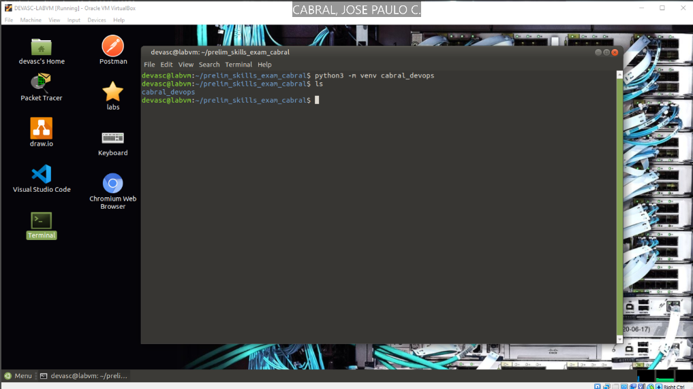

2. Activate the virtual environment.

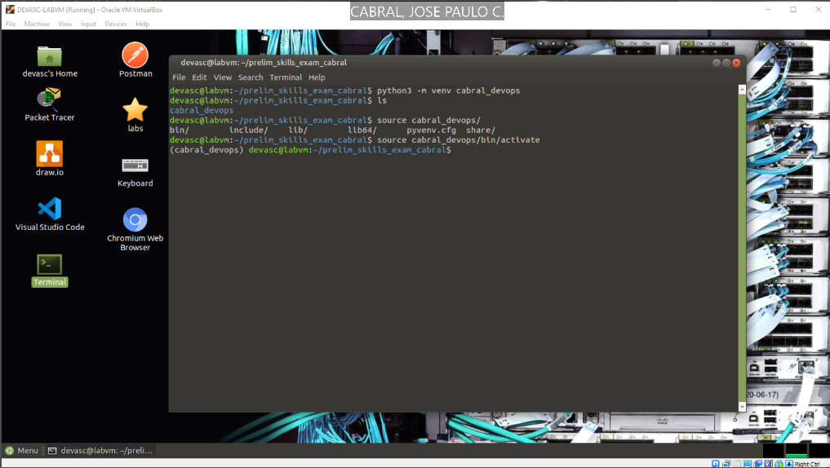

3. Execute a command to check what packages are installed in the system environment.

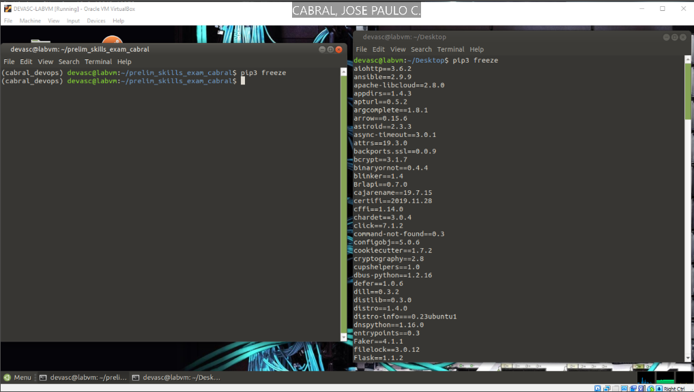

4. Create requirements.txt and, then execute a command to install the packages as stated in the requirements.txt (Note: Install at least four (4) packages)

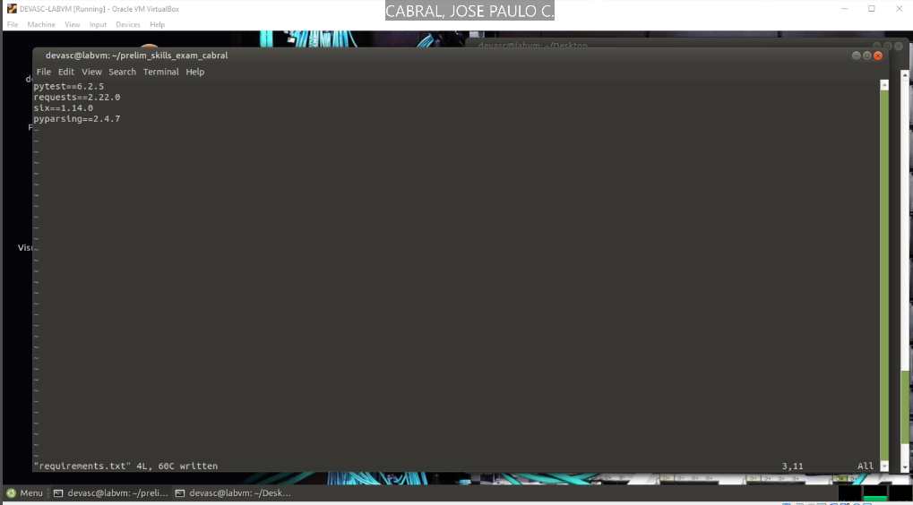

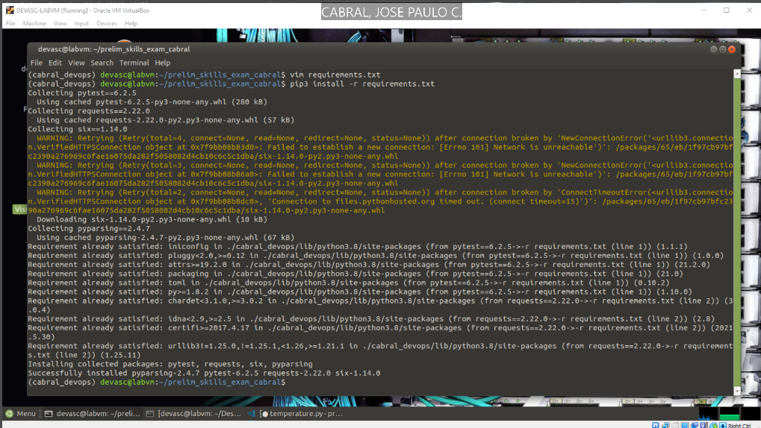

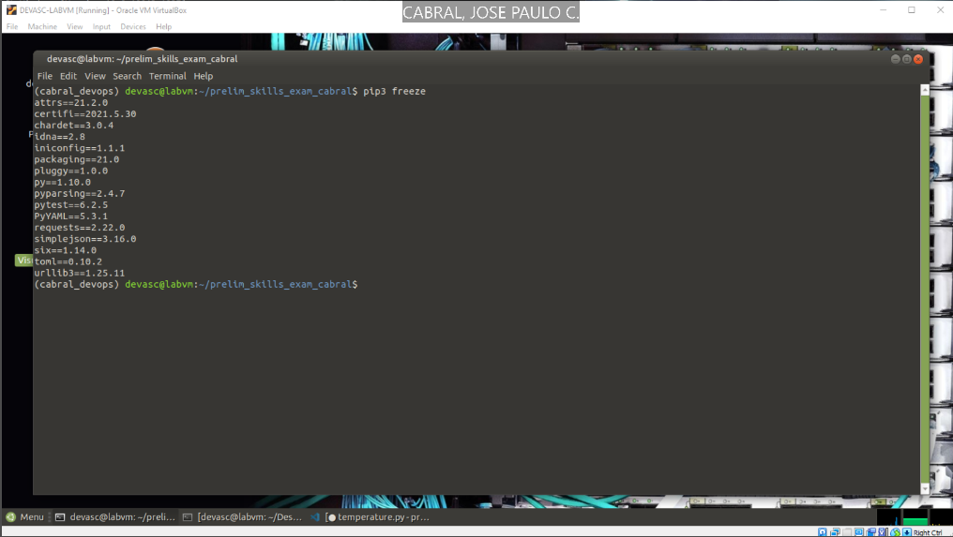

B. Create a python Unit Test (15 points) Create at least 4 test cases of the python unit test to test the given python script.

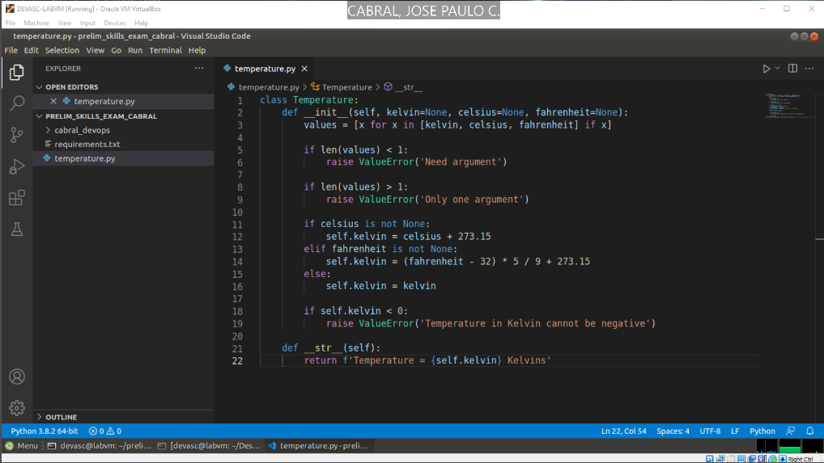

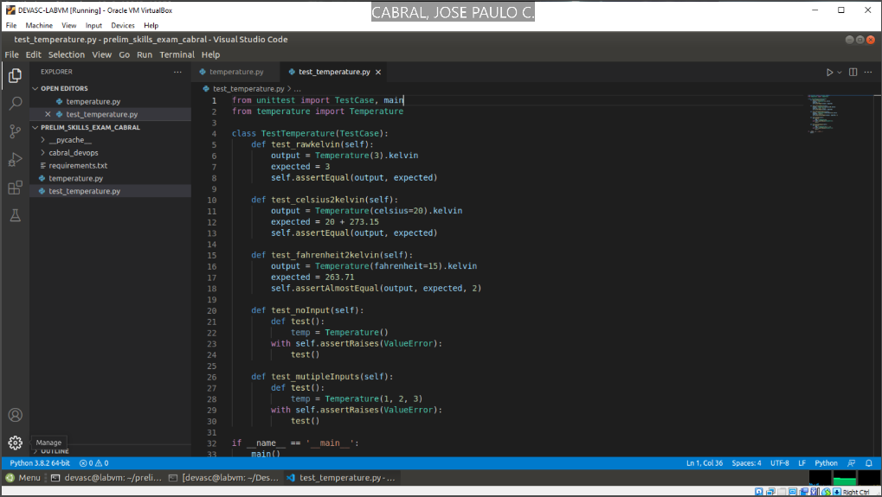

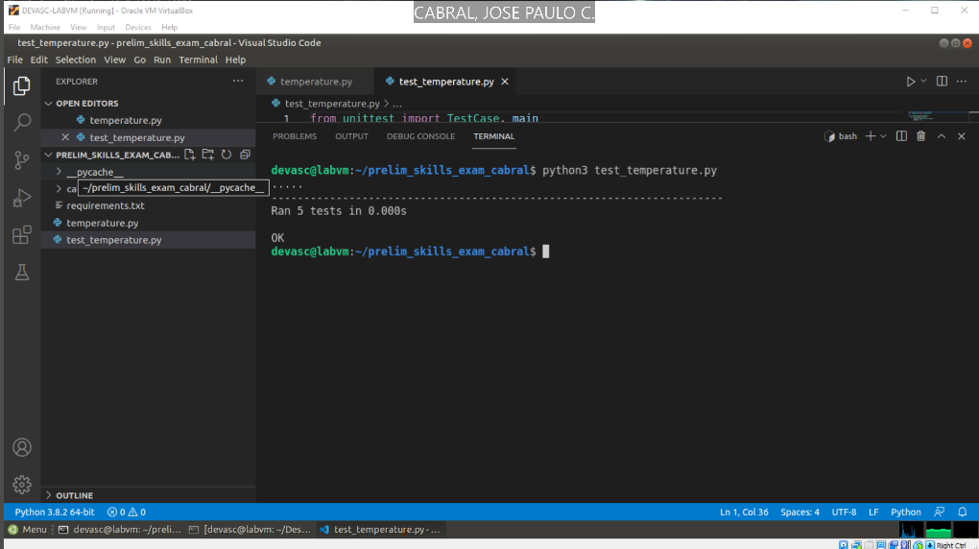

C. Parsing Different Data Types with Python (20 points)

Parse the given JSON / XML file for COVID cases. Retrieve the date reported, countries and territories, number of cases, and deaths. Create a new CSV file and then save the retrieved data to the CSV file.

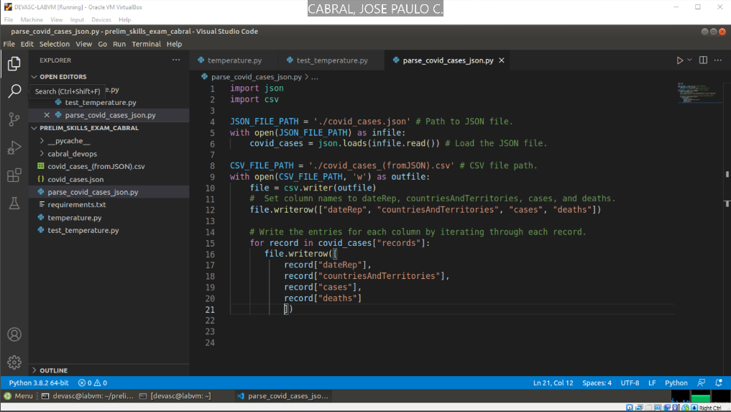

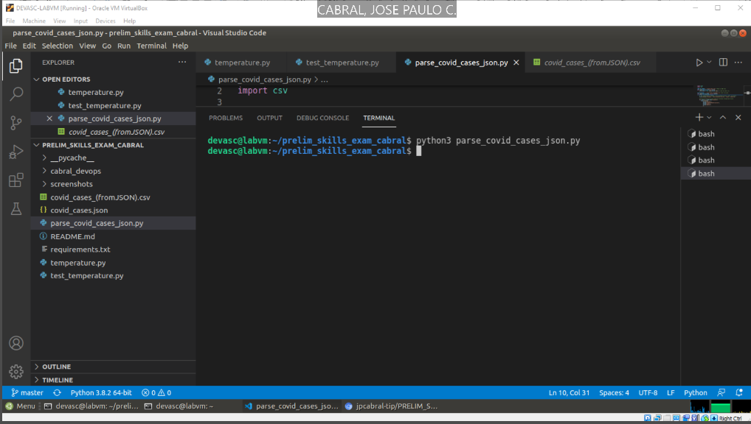

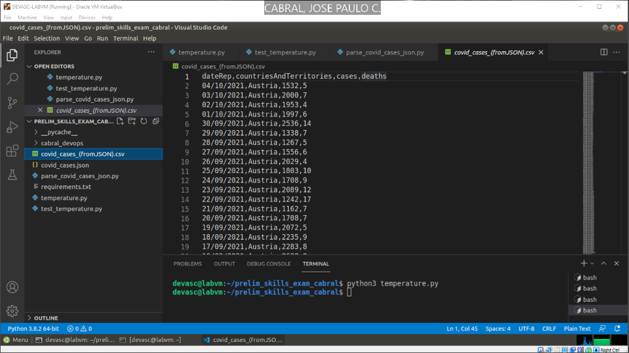

D. Git Commands (5 points)

1. Create a repository PRELIM_SKILLS_EXAM to your GITHUB account.

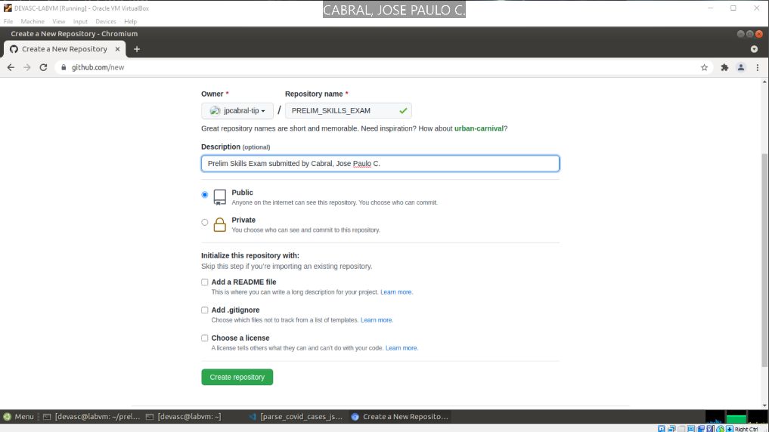

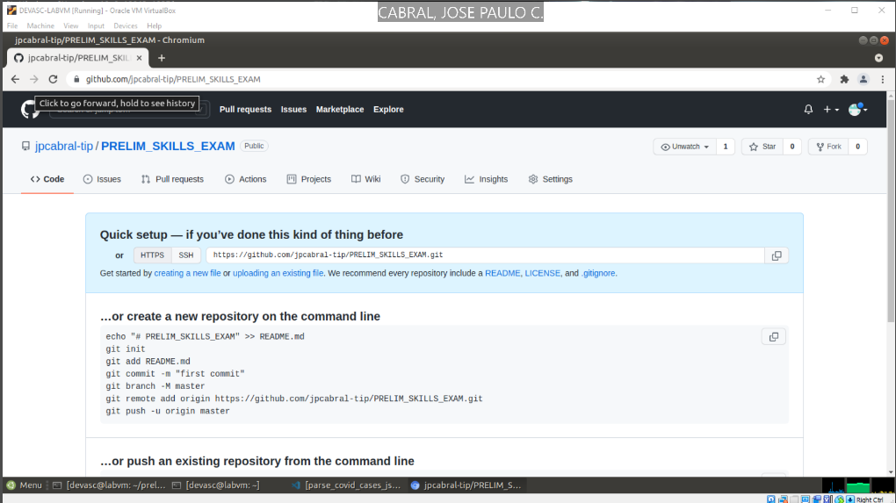

2. Upload your files using the GIT command. Make sure to include the necessary comments.

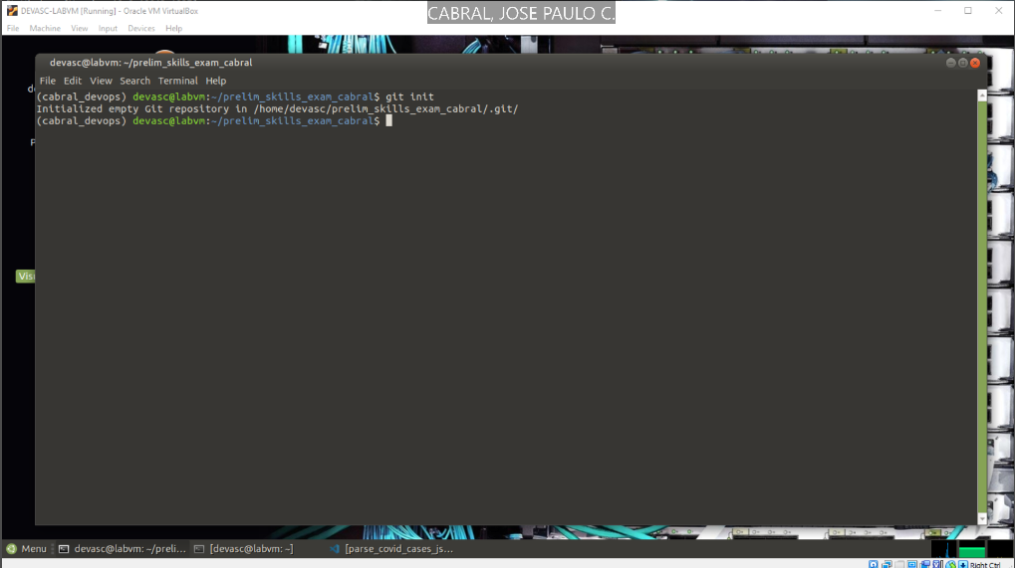

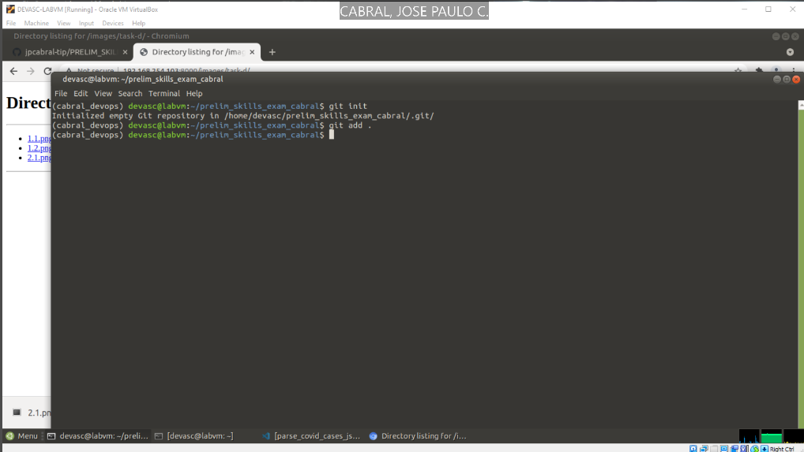

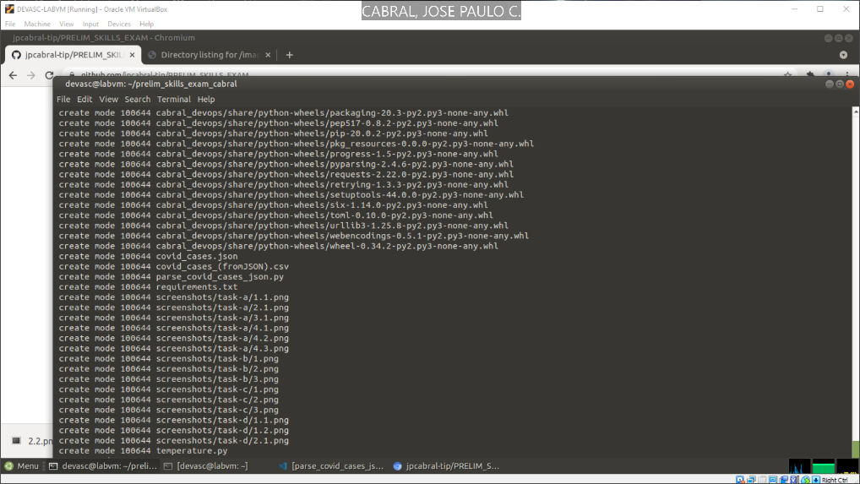

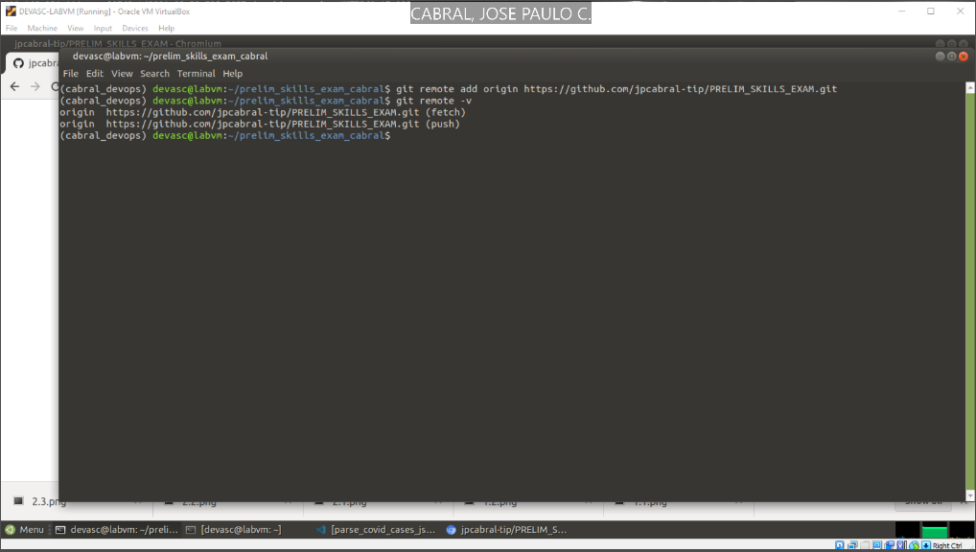

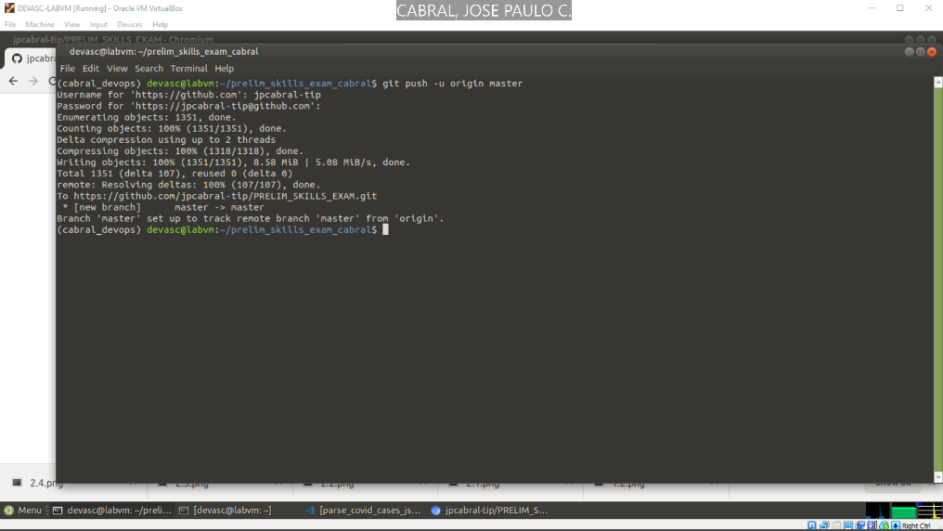

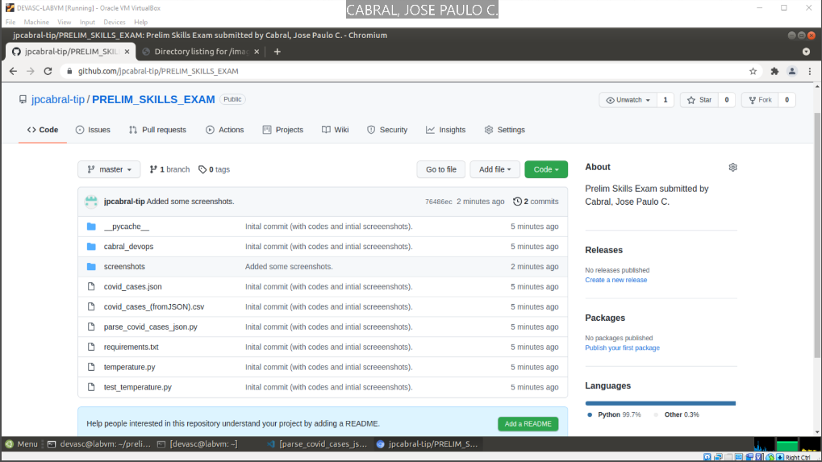

**Github repository link:** <https://github.com/jpcabral-tip/PRELIM_SKILLS_EXAM>